LIBRARY MANAGEMENT PLATFORM
Unit 1: Product Engineering & Design Thinking
Training & Technical Project Document
Careertiq Training & Engineering Division
STUDENT DETAILS
Name: pranav jadhav
PRN:2125UMLM1083
Course: B.Tech CSE (AIML)
Year: Second Year
University: Sanjivani University, Kopargaon
GitHub Repository
https://github.com/pranavjadhav4484 -crypto/library-mangment_platform.git
Submission Document

1. Business Problem Statement & Business Justification

Business Domain
Academic Library Services.

Core Problem Statement
Library members experience severe operational delays in locating, reserving, borrowing, and returning literary resources due to inefficient manual tracking. Concurrently, administrative staff lack centralized real-time visibility, leading to unrecorded losses, reporting errors, and poor user satisfaction.

Core Library Operations
- Book Acquisition & Cataloging
- Membership Management
- Search & Circulation Workflow
- Financial Penalties
- Administrative Analytics

Manual Challenges and Automated Solutions
Manual Bottleneck | Automated Platform Solution | Business Outcome
Physical searching across card catalogs | Indexed database with multi-field search engine | Search time reduced from 25 min to <5 seconds
Manual paper ledger entries for checkout | Automated barcode/QR scanner integration | Queue processing speed improved by 80%
Manual tracking of overdue items | Cron-driven notification system and dynamic fine calculation | Overdue return rates decreased by 40%
Human error, lost records and missing inventory | Relational database with strict integrity constraints | Record accuracy brought to 99.9%

2. Product Vision & MVP Feature Matrix

Product Vision Statement
"To deliver a modern, automated, and cloud-native Library Management Platform that eliminates manual administrative overhead, streamlines circulation workflows, and delivers an intuitive digital catalog experience for academic communities."

MVP Release Scope
MVP Feature | Description
User Login & Profile RBAC | Role-based access for users
Book Search & Availability Status | Search books and view availability
Basic Issue & Return Transaction Management | Manage circulation transactions
Automated Fine Calculation Logic | Calculate overdue penalties
Basic Administrative Reporting | Provide basic administrative reports
Deferred Capabilities: AI book recommendations and third-party payment gateways are deferred from the MVP.

3. Stakeholder Responsibility Matrix & User Personas

User Personas

Aarav — Student
Objective: Find academic references fast and avoid late fines.
Frustrations: Long physical queues and unexpected fine accumulation.
Target Features: Mobile search portal and push/email due-date alerts.

Mrs. Sunita — Librarian
Objective: Process checkouts quickly and maintain accurate catalog inventory.
Frustrations: Manual record entries, stock discrepancies and lost books.
Target Features: Barcode issue/return interface and automated fine tracker.

Dr. Verma — Library Administrator
Objective: Monitor library utilization and generate departmental compliance reports.
Frustrations: Lack of real-time usage data and manual report generation taking days.
Target Features: Executive analytics dashboard with 1-click PDF export.

Stakeholder Matrix
Stakeholder Group | Key Roles | Responsibilities & Expectations
Business Stakeholders | College Management, Library Admin, Students, Faculty | Define business vision, validate functional usability, ensure domain compliance
Engineering Stakeholders | Software Developers, UI/UX Designers, QA Engineers | Architect codebase, build responsive frontends, write unit tests, ensure high quality
Operations Stakeholders | DevOps Engineers, Database Administrators, Security Team | Provision cloud infrastructure, maintain database integrity, automate CI/CD pipelines

4. Functional & Non-Functional Requirements

Functional Requirements
FR-01 Authentication: Secure Role-Based Access Control (RBAC) for Admin, Librarian, Student, and Faculty.
FR-02 Book Catalog Management: Full CRUD operations for books, authors, categories, and physical shelf coordinates.
FR-03 Circulation Engine: Automated check-out and check-in processing with inventory increment/decrement.
FR-04 Fine Engine: Automated background processing calculating overdue penalties based on user tier.
FR-05 Notification System: Triggered email alerts for upcoming due dates and overdue fines.

Non-Functional Requirements
NFR-01 Security: Password hashing (Bcrypt/Argon2), JWT token session management, and HTTPS encryption.
NFR-02 Performance: Sub-500ms API response time for search queries under concurrent user load.
NFR-03 Availability & Scalability: Containerized deployment targeting 99.9% uptime with horizontal pod autoscaling.
NFR-04 Maintainability: Infrastructure as Code (IaC) modularity and clear codebase separation.

5. Design Thinking Report

Stage 1 — Empathize
The key user categories are:
- Students
- Faculty Members
- Librarians
- System Administrators
The objective is to understand users in their natural library workflow.

Stage 2 — Define
Core Problem Statement: "Library members experience severe operational delays in locating, reserving, borrowing, and returning literary resources due to inefficient manual tracking. Concurrently, administrative staff lack centralized real-time visibility, leading to unrecorded losses, reporting errors, and poor user satisfaction."

Stage 3 — Ideate
- Automated email/SMS reminders
- Dynamic QR code membership cards
- Mobile self-checkout
- Live inventory dashboards
- Automated penalty generation

Stage 4 — Prototype
- Login Page
- User Search Portal
- Librarian Checkout Dashboard
- Admin Analytics Panel

Stage 5 — Test
Paper prototypes are demonstrated to students and library staff to evaluate navigation flows, layout clarity, and task completion speed before frontend engineering.

6. IBM Design Thinking & IBM Loop

IBM Design Thinking

Focus on User Outcomes
Shift technical goals to measurable human outcomes.
Feature Goal: Build a catalog database search query.
Outcome Focus: Enable students to locate and reserve any book in under 3 clicks.

Restless Reinvention
Treat continuous deployment as an ongoing refinement cycle, continuously analyzing production usage to improve UI layout and backend response speed.

Diverse Empowered Teams
- Product Managers
- UX Designers
- Software Engineers
- QA
- Database Administrators
- DevOps Engineers

IBM Loop Engine
OBSERVE → REFLECT → MAKE → OBSERVE
OBSERVE: Study user interactions, logs and operational friction.
REFLECT: Analyze metrics, align priorities and re-evaluate.
MAKE: Design UI, write code and automate CI/CD deployment.

7. Multi-Phase Product Engineering Roadmap
- Phase 1: Domain Analysis & Problem Understanding
- Phase 2: Design Thinking & Prototyping
- Phase 3: Agile Sprint Planning & Backlog Management
- Phase 4: Core Application Development (Backend & Frontend)
- Phase 5: DevOps Automation (CI/CD Pipelines & Containerization)
- Phase 6: Infrastructure Automation (Terraform & Ansible)
- Phase 7: Production Deployment & Monitoring (Kubernetes, Prometheus, Grafana)

8. System Architecture Diagram Concept
LIBRARY MANAGEMENT PLATFORM
|
+----------------+----------------+
| | |
v v v
Student Portal Librarian UI Admin Dashboard
| | |
+----------------+----------------+
|
Application / API Layer
|
+----------------+----------------+
| | |
v v v
Authentication Catalog Module Circulation
| | |
+----------------+----------------+
|
Database / Data Layer
|
+----------------+----------------+
| | |
v v v
User Data Library Data Transaction Data
|
+----------+----------+
| | |
v v v
Fines Notifications Reports

9. Repository Architecture
library-management-platform/
├── .github/
├── app/
│ ├── modules/
│ ├── database/
│ └── tests/
├── docs/
├── docker/
├── kubernetes/
├── terraform/
├── ansible/
├── monitoring/
└── README.md

10. GitHub Repository & Submission Details
Repository: library-management-platform
Branch: main
Commit message: docs: complete Unit 1 product engineering deliverables
Repository status: Working tree clean after push.
The repository contains the required top-level architecture and the Unit 1 deliverables document.

11. Trainer Execution Deliverables Checklist
✓ Business Problem Statement & Business Justification Report
✓ Product Vision Statement & MVP Feature Matrix
✓ Stakeholder Responsibility Matrix & User Persona Profiles
✓ Functional (FRS) and Non-Functional (NFRS) Requirements Specs
✓ Design Thinking Report (Empathize, Define, Ideate, Prototype, Test)
✓ IBM Design Thinking & IBM Loop Execution Specs
✓ Multi-Phase Product Engineering Roadmap
✓ System Architecture Diagram Concept Specs
✓ Initialized Git Repository & Standardized Folder Architecture

12. Screenshot Evidence
The following screenshots document the execution and GitHub submission of the Unit 1 assignment.
Screenshot 1 — Local VS Code repository architecture
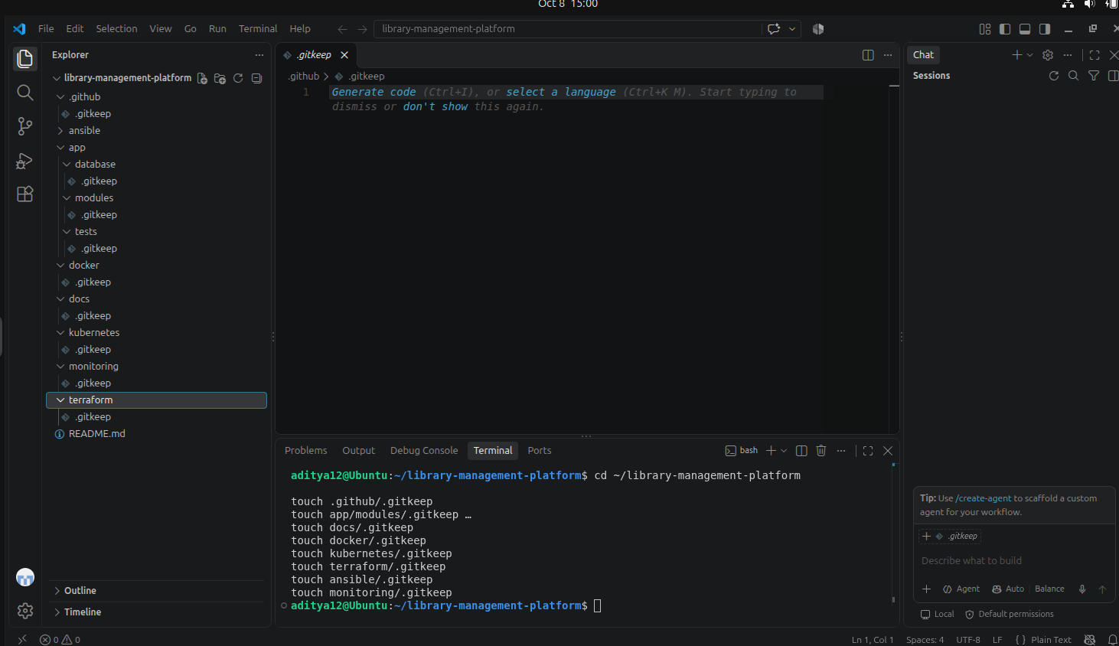
Screenshot 2 — Unit 1 deliverables document in VS Code
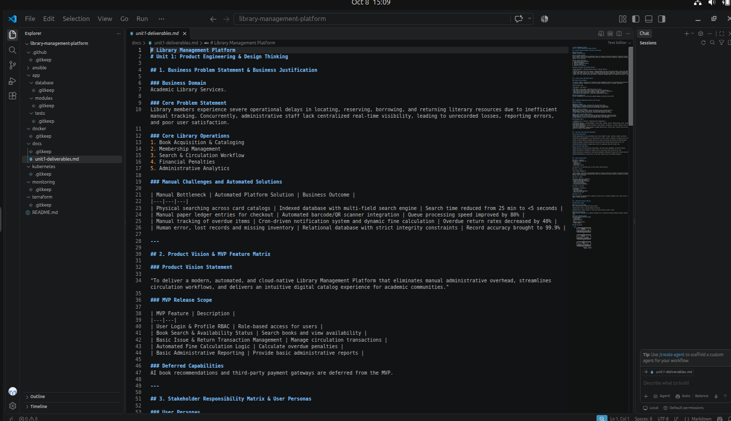
Screenshot 3 — Git commit and Git history
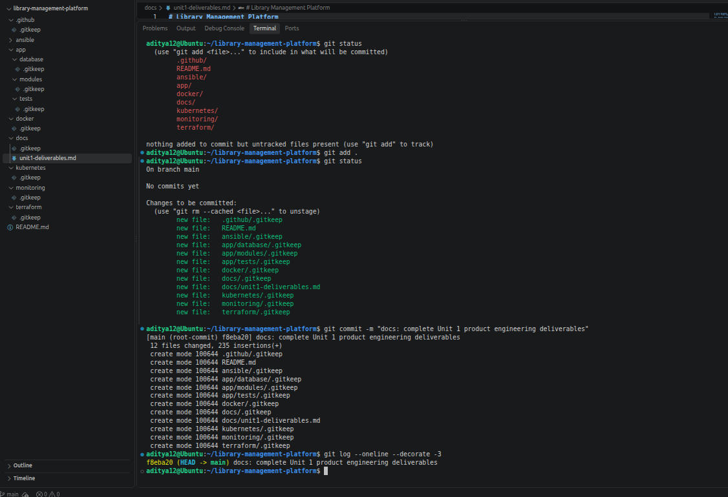
Screenshot 4 — Successful GitHub push and clean working tree
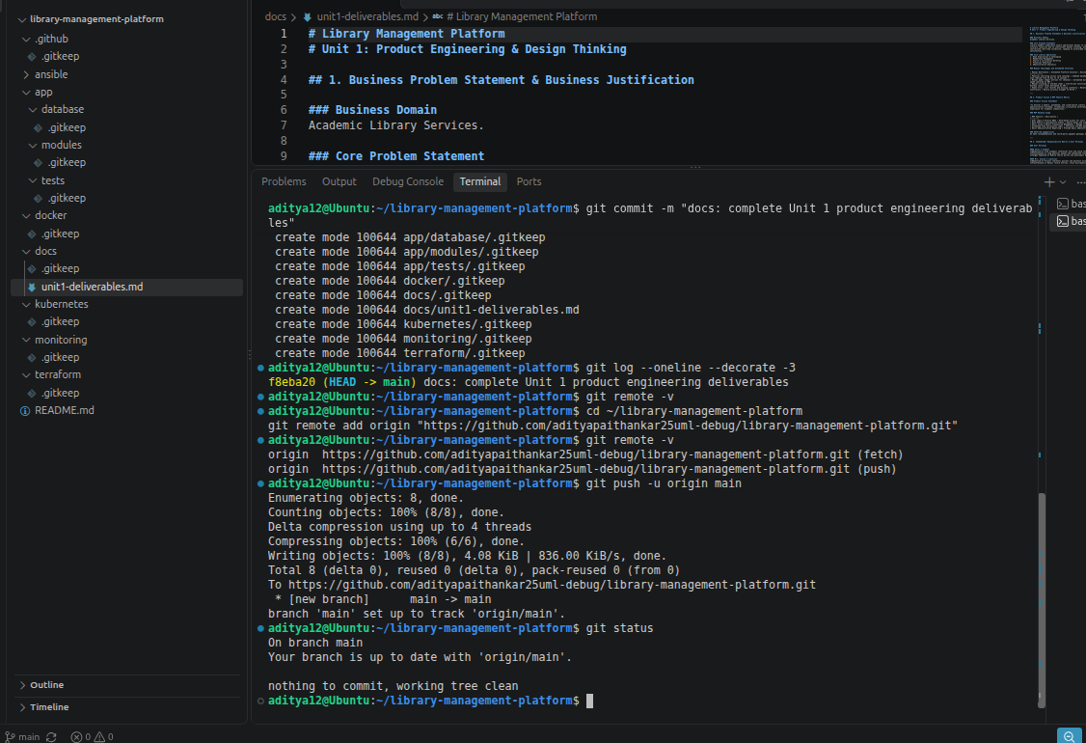
Screenshot 5 — GitHub repository with required folder structure
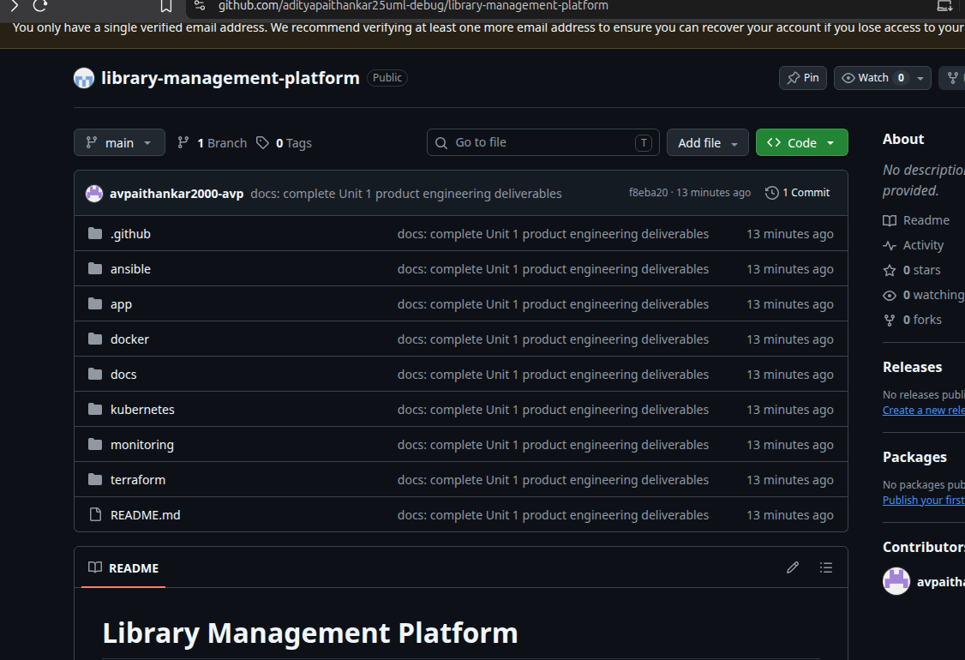
Screenshot 6 — GitHub-rendered Unit 1 deliverables
